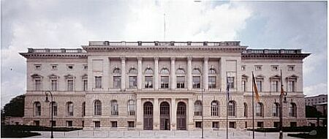

The Study Foundation of the Berlin House of Representatives offers scholarships for graduate students and postdocs coming from the former Allied countries of World War II, who want to study at a Berlin university or use research facilities in Berlin.

We cordially welcome interested students and scholars from all fields of study to apply!

The foundation will award 15 grants for the academic year 2026/27. The grants amount to 1,100 EUR for graduate and doctoral students; and 1,630 EUR for postdocs per month.

The application deadline is 15 December 2025. The program will start on 1 October 2026 and end on 31 July 2027: <http://www.parlament-berlin.de/de/Das-Parlament/Studienstiftung>